**ASSIGNMENT 4**

|  |  |
| --- | --- |
| Date | 08 November 2022 |
| Team ID | PNT2022TMID11446 |
| Project Name | Industry-specific intelligent fire management system |
| Maximum Marks | 8 Marks |

**INPUT:**

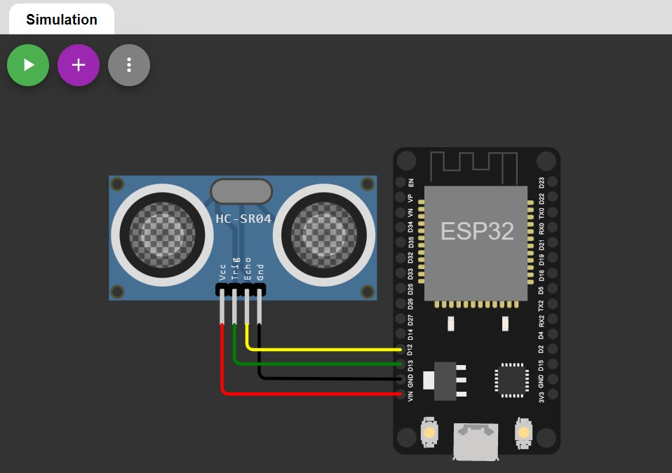

**CODE:**

#include <stdio.h>

#include <stdbool.h>

#include <freertos/FreeRTOS.h>

#include <freertos/task.h>

#include <esp_err.h>

#include "ultrasonic.h#define ECHO_GPIO 12

#define TRIGGER_GPIO 13

#define MAX_DISTANCE_CM 500 // Maximum of 5 meters

void ultrasonic_test(void *pvParameters)

{ float distance;

ultrasonic_sensor_t sensor = { .trigger_pin = TRIGGER_GPIO,

.echo_pin = ECHO_GPIO

};

ultrasonic_init(&sensor);

while (true) {esp_err_t res = ultrasonic_measure(&sensor, MAX_DISTANCE_CM, &distance);

if (res == ESP_OK) { printf("Distance: %0.04f m\n", distance);

} // Print error else { printf("Error %d: ", res); switch (res) { case ESP_ERR_ULTRASONIC_PING:

printf("Cannot ping (device is in invalid state)\n"); break; case ESP_ERR_ULTRASONIC_PING_TIMEOUT:

printf("Ping timeout (no device found)\n"); break;

case ESP_ERR_ULTRASONIC_ECHO_TIMEOUT:

printf("Echo timeout (i.e. distance too big)\n"); break; default:

printf("%s\n", esp_err_to_name(res));

}

}

vTaskDelay(pdMS_TO_TICKS(500));

}

}

void app_main()

{ xTaskCreate(ultrasonic_test, "ultrasonic_test",

configMINIMAL_STACK_SIZE * 3, NULL, 5, NULL);

}

**OUTPUT:**

